Option 1:

* open terminal
* Type: “npx cypress run –spec \*\*\*relative file path eg: cypress/e2e/positive.cy.js \*\*\*”



Option 2

Npx cypress open



Configure E2E testing

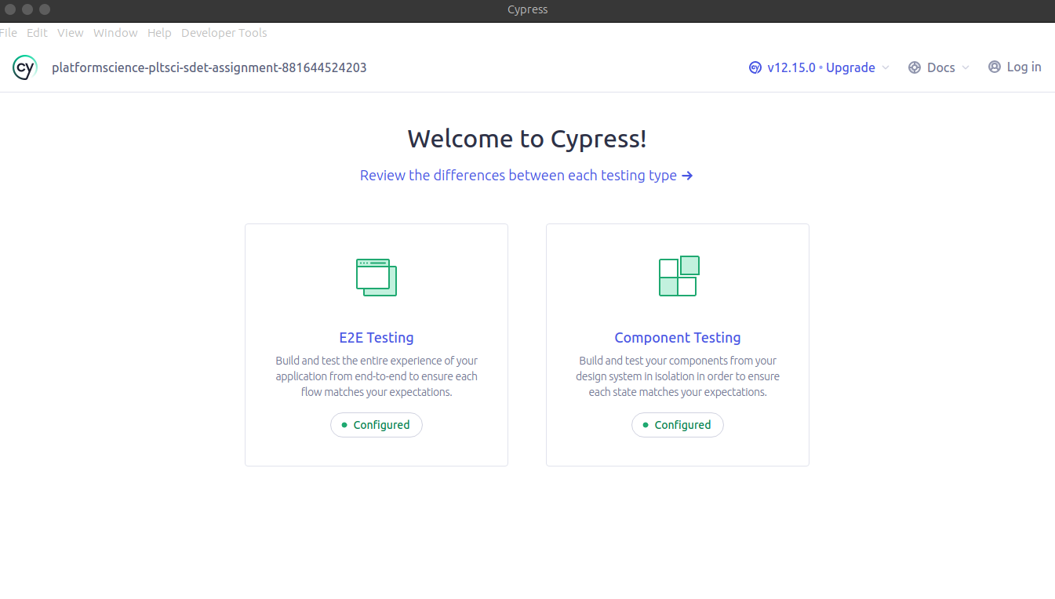

Select the browser of your preference

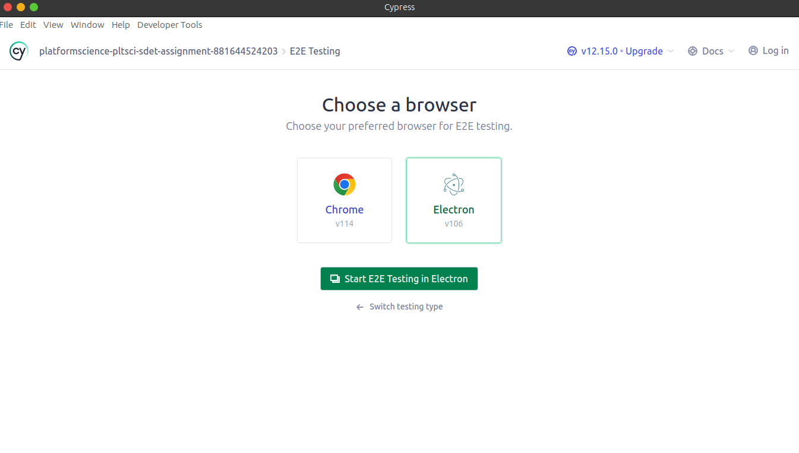

Select a specs file to run

